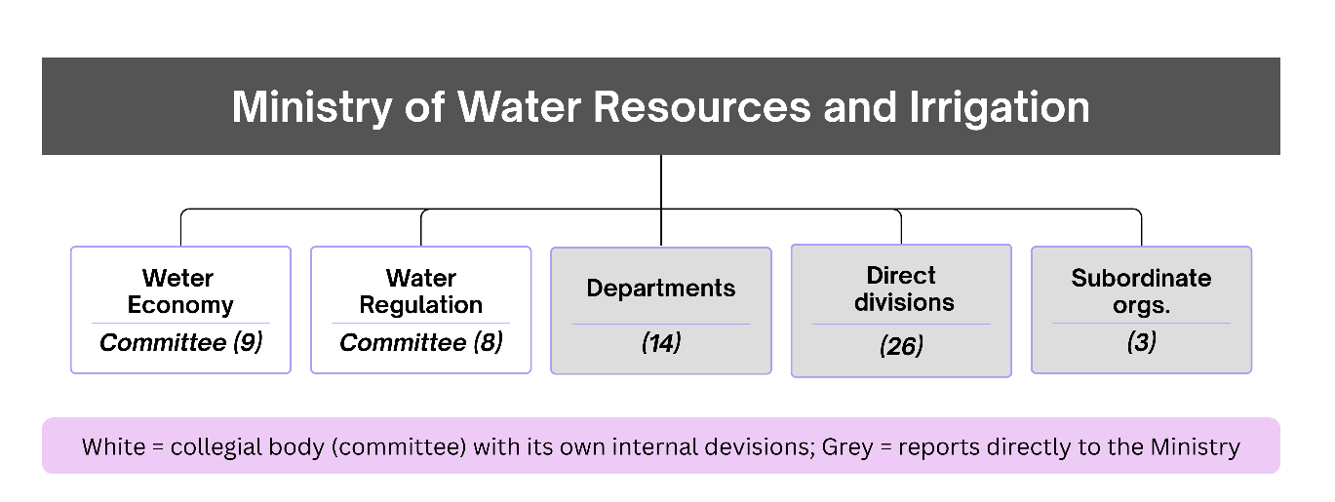
Figure S1: Organizational structure of the ministry, comprising two collegial bodies (committees) with internal divisions, together with flat administrative units, including departments, direct divisions, and subordinate organizations reporting directly to the Ministry.

Table S1: Full listing of organizational units within the Ministry of Water Resources and Irrigation of the Republic of Kazakhstan (n = 60), by category and parent body.
No. | Category | Unit name | Parent body
1 | Committee division | Consolidated analysis and monitoring | Committee of Water Economy
2 | Committee division | Group water pipeline development | Committee of Water Economy
3 | Committee division | Hydro-ameliorative systems development | Committee of Water Economy
4 | Committee division | Water facility and irrigation systems development | Committee of Water Economy
5 | Committee division | HR and administrative affairs | Committee of Water Economy
6 | Committee division | Legal support | Committee of Water Economy
7 | Committee division | Budget planning and program implementation | Committee of Water Economy
8 | Committee division | State assets and accounting | Committee of Water Economy
9 | Committee division | Design and survey works | Committee of Water Economy
10 | Committee division | Water use regulation | Committee of Water Regulation
11 | Committee division | State control of water use | Committee of Water Regulation
12 | Committee division | State water accounting and cadastre | Committee of Water Regulation
13 | Committee division | Budget planning and accounting | Committee of Water Regulation
14 | Committee division | Consolidated analysis and monitoring | Committee of Water Regulation
15 | Committee division | Water resources protection | Committee of Water Regulation
16 | Committee division | Legal support and procurement | Committee of Water Regulation
17 | Committee division | HR and administrative affairs | Committee of Water Regulation
18 | Department | Digitalization | Ministry (direct)
19 | Department | Water facilities development | Ministry (direct)
20 | Department | Water-saving technologies development | Ministry (direct)
21 | Department | Strategic development | Ministry (direct)
22 | Department | Administrative affairs | Ministry (direct)
23 | Department | Tariff policy regulation | Ministry (direct)
24 | Department | Legal service | Ministry (direct)
25 | Department | Finance | Ministry (direct)
26 | Department | Internal audit | Ministry (direct)
27 | Department | HR affairs | Ministry (direct)
28 | Department | International cooperation | Ministry (direct)
29 | Department | Groundwater | Ministry (direct)
30 | Department | Water policy | Ministry (direct)
31 | Department | Science and innovation | Ministry (direct)
32 | Division | Regulatory publication and public communication | Ministry (direct)
33 | Division | International organization relations | Ministry (direct)
34 | Division | Methodology and public services | Ministry (direct)
35 | Division | Budget execution and procurement | Ministry (direct)
36 | Division | Budget planning | Ministry (direct)
37 | Division | Groundwater and irrigated-land monitoring | Ministry (direct)
38 | Division | Natural monopoly control | Ministry (direct)
39 | Division | State water policy | Ministry (direct)
40 | Division | Project management | Ministry (direct)
41 | Division | Agricultural water-saving technology | Ministry (direct)
42 | Division | Editorial review and logistics | Ministry (direct)
43 | Division | Irrigation and drainage | Ministry (direct)
44 | Division | Innovation policy | Ministry (direct)
45 | Division | Internal control | Ministry (direct)
46 | Division | Personnel development | Ministry (direct)
47 | Division | Water sector digitalization | Ministry (direct)
48 | Division | Document flow and citizen requests | Ministry (direct)
49 | Division | Automation and service quality control | Ministry (direct)
50 | Division | Central Asia water cooperation | Ministry (direct)
51 | Division | Development program implementation | Ministry (direct)
52 | Division | Hydrotechnical facilities | Ministry (direct)
53 | Division | Water use tariffication | Ministry (direct)
54 | Division | China and Russia water cooperation | Ministry (direct)
55 | Division | Water sector workforce development | Ministry (direct)
56 | Division | Groundwater exploration and survey | Ministry (direct)
57 | Division | Strategic planning and analysis | Ministry (direct)
58 | Subordinate organization | NC "Kazgidrogeologiya" | Ministry (subordinate)
59 | Subordinate organization | Water Resources Information-Analytical Center | Ministry (subordinate)
60 | Subordinate organization | RSE "Kazvodkhoz" | Ministry (subordinate)

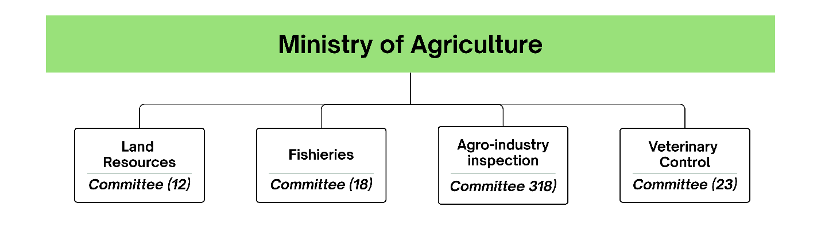
Figure S2: Simplified organizational structure of the Ministry of Agriculture of the Republic of Kazakhstan. Central-apparatus functions are distributed across four committees, each comprising internal divisions, territorial inspections, and subordinate organizations. Full unit names, organizational categories, and committee affiliations are provided in Table S2.

Table S2: Full listing of organizational units within the Ministry of Agriculture of the Republic of Kazakhstan (n = 84), by category and parent committee.

No. | Category | Unit name | Parent committee
1 | Division | Land use monitoring | Land Resources Committee
2 | Division | Land management | Land Resources Committee
3 | Division | Land relations development | Land Resources Committee
4 | Division | Soil resources and climate-resilient agriculture development | Land Resources Committee
5 | Division | Documentation and media relations | Land Resources Committee
6 | Division | Digitalization and public services | Land Resources Committee
7 | Division | Public procurement | Land Resources Committee
8 | Division | Budget planning and accounting | Land Resources Committee
9 | Division | Personnel affairs | Land Resources Committee
10 | Division | Legal support | Land Resources Committee
11 | Division | State land cadastre | Land Resources Committee
12 | Division | State control over land use and protection | Land Resources Committee
13 | Division | Fish resource protection and fisheries regulation | Fisheries Committee
14 | Division | Aquaculture development | Fisheries Committee
15 | Division | Fish stock reproduction and scientific support | Fisheries Committee
16 | Division | Finance and accounting | Fisheries Committee
17 | Division | Public procurement | Fisheries Committee
18 | Division | Personnel, organizational and legal affairs | Fisheries Committee
19 | Territorial unit | Zhaiyk-Caspian interregional fisheries basin inspection | Fisheries Committee
20 | Territorial unit | Zaisan-Irtysh interregional fisheries basin inspection | Fisheries Committee
21 | Territorial unit | Nura-Sarysu interregional fisheries basin inspection | Fisheries Committee
22 | Territorial unit | Tobol-Torgai interregional fisheries basin inspection | Fisheries Committee
23 | Territorial unit | Shu-Talas interregional fisheries basin inspection | Fisheries Committee
24 | Territorial unit | Aral-Syrdarya interregional fisheries basin inspection | Fisheries Committee
25 | Territorial unit | Balkhash-Alakol interregional fisheries basin inspection | Fisheries Committee
26 | Territorial unit | Yesil interregional fisheries basin inspection | Fisheries Committee
27 | Subordinate organization | Scientific-Production Center of Fisheries (LLP) | Fisheries Committee
28 | Subordinate organization | Atyrau Sturgeon Fish-Breeding Plant (state enterprise) | Fisheries Committee
29 | Subordinate organization | Kamyshlybash Fish Hatchery (state enterprise) | Fisheries Committee
30 | Subordinate organization | Petropavlovsk Fish Hatchery (state enterprise) | Fisheries Committee
31 | Division | State control of livestock breeding, grain and seed production | Agro-Industry Inspection Committee
32 | Division | International relations and digitalization | Agro-Industry Inspection Committee
33 | Division | Budget planning and accounting | Agro-Industry Inspection Committee
34 | Division | Regulatory drafting and legal support | Agro-Industry Inspection Committee
35 | Division | Organizational control and personnel affairs | Agro-Industry Inspection Committee
36 | Division | Public procurement | Agro-Industry Inspection Committee
37 | Division | Plant quarantine | Agro-Industry Inspection Committee
38 | Division | Plant protection | Agro-Industry Inspection Committee
39 | Territorial unit | Territorial inspection - Abai region | Agro-Industry Inspection Committee
40 | Territorial unit | Territorial inspection - Ulytau region | Agro-Industry Inspection Committee
41 | Territorial unit | Territorial inspection - Zhetysu region | Agro-Industry Inspection Committee
42 | Territorial unit | Territorial inspection - Almaty city | Agro-Industry Inspection Committee
43 | Territorial unit | Territorial inspection - Shymkent city | Agro-Industry Inspection Committee
44 | Territorial unit | Territorial inspection - Astana city | Agro-Industry Inspection Committee
45 | Territorial unit | Territorial inspection - Turkestan region | Agro-Industry Inspection Committee
46 | Territorial unit | Territorial inspection - North Kazakhstan region | Agro-Industry Inspection Committee
47 | Territorial unit | Territorial inspection - Pavlodar region | Agro-Industry Inspection Committee
48 | Territorial unit | Territorial inspection - Mangystau region | Agro-Industry Inspection Committee
49 | Territorial unit | Territorial inspection - Kyzylorda region | Agro-Industry Inspection Committee
50 | Territorial unit | Territorial inspection - Kostanay region | Agro-Industry Inspection Committee
51 | Territorial unit | Territorial inspection - Karaganda region | Agro-Industry Inspection Committee
52 | Territorial unit | Territorial inspection - West Kazakhstan region | Agro-Industry Inspection Committee
53 | Territorial unit | Territorial inspection - Zhambyl region | Agro-Industry Inspection Committee
54 | Territorial unit | Territorial inspection - East Kazakhstan region | Agro-Industry Inspection Committee
55 | Territorial unit | Territorial inspection - Atyrau region | Agro-Industry Inspection Committee
56 | Territorial unit | Territorial inspection - Almaty region | Agro-Industry Inspection Committee
57 | Territorial unit | Territorial inspection - Aktobe region | Agro-Industry Inspection Committee
58 | Territorial unit | Territorial inspection - Akmola region | Agro-Industry Inspection Committee
59 | Subordinate organization | Republican Plant Quarantine Center (state institution) | Agro-Industry Inspection Committee
60 | Subordinate organization | "Phytosanitary" (republican state enterprise) | Agro-Industry Inspection Committee
61 | Subordinate organization | Republican Methodological and Forecasting Center for Plant Diagnostics (state institution) | Agro-Industry Inspection Committee
62 | Territorial unit | Territorial inspection - Almaty city | Veterinary Control Committee
63 | Territorial unit | Territorial inspection - Astana city | Veterinary Control Committee
64 | Territorial unit | Territorial inspection - Shymkent city | Veterinary Control Committee
65 | Territorial unit | Territorial inspection - Akmola region | Veterinary Control Committee
66 | Territorial unit | Territorial inspection - Aktobe region | Veterinary Control Committee
67 | Territorial unit | Territorial inspection - Almaty region | Veterinary Control Committee
68 | Territorial unit | Territorial inspection - Atyrau region | Veterinary Control Committee
69 | Territorial unit | Territorial inspection - East Kazakhstan region | Veterinary Control Committee
70 | Territorial unit | Territorial inspection - Zhambyl region | Veterinary Control Committee
71 | Territorial unit | Territorial inspection - West Kazakhstan region | Veterinary Control Committee
72 | Territorial unit | Territorial inspection - Karaganda region | Veterinary Control Committee
73 | Territorial unit | Territorial inspection - Kostanay region | Veterinary Control Committee
74 | Territorial unit | Territorial inspection - Kyzylorda region | Veterinary Control Committee
75 | Territorial unit | Territorial inspection - Mangystau region | Veterinary Control Committee
76 | Territorial unit | Territorial inspection - Pavlodar region | Veterinary Control Committee
77 | Territorial unit | Territorial inspection - North Kazakhstan region | Veterinary Control Committee
78 | Territorial unit | Territorial inspection - Turkestan region | Veterinary Control Committee
79 | Territorial unit | Territorial inspection - Ulytau region | Veterinary Control Committee
80 | Territorial unit | Territorial inspection - Abai region | Veterinary Control Committee
81 | Territorial unit | Territorial inspection - Zhetysu region | Veterinary Control Committee
82 | Subordinate organization | Republican Anti-Epizootic Detachment (state institution) | Veterinary Control Committee
83 | Subordinate organization | Republican Veterinary Laboratory (republican state enterprise) | Veterinary Control Committee
84 | Subordinate organization | National Veterinary Reference Center (republican state enterprise) | Veterinary Control Committee

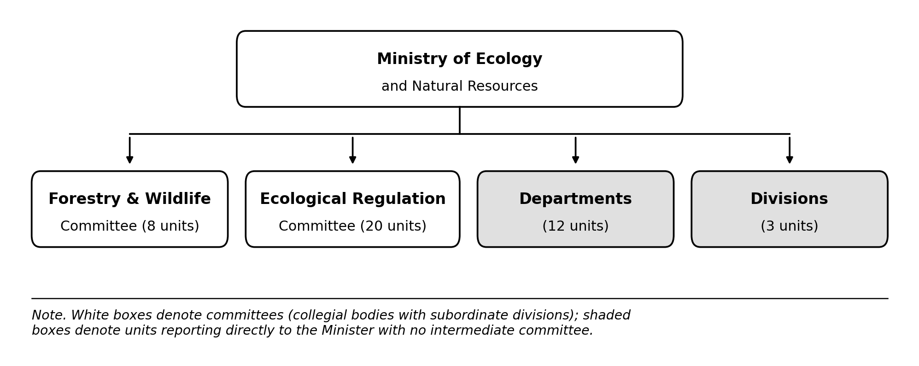
Figure S3: Simplified organizational structure of the Ministry of Ecology and Natural Resources of the Republic of Kazakhstan. Central-apparatus functions are distributed across two committees: one organized into functional divisions and the other into twenty regional (territorial) departments, alongside departments and divisions that report directly to the Minister. Full unit names, organizational categories, and parent bodies are provided in Table S3.

Table S3: Full listing of organizational units within the Ministry of Ecology and Natural Resources of the Republic of Kazakhstan (n = 43), by category and parent body.

No. | Category | Unit name | Parent body
1 | Committee division | State control, protection and defense of forests | Forestry and Wildlife Committee
2 | Committee division | Forest and flora reproduction and use | Forestry and Wildlife Committee
3 | Committee division | Wildlife and hunting economy | Forestry and Wildlife Committee
4 | Committee division | Budget planning and accounting | Forestry and Wildlife Committee
5 | Committee division | Public procurement organization | Forestry and Wildlife Committee
6 | Committee division | Legal support | Forestry and Wildlife Committee
7 | Committee division | Personnel and administrative affairs | Forestry and Wildlife Committee
8 | Committee division | Specially protected natural areas | Forestry and Wildlife Committee
9 | Territorial department | Ecology Department: Ulytau region | Ecological Regulation and Control Committee
10 | Territorial department | Ecology Department: Almaty region | Ecological Regulation and Control Committee
11 | Territorial department | Ecology Department: Abai region | Ecological Regulation and Control Committee
12 | Territorial department | Ecology Department: Zhetysu region | Ecological Regulation and Control Committee
13 | Territorial department | Ecology Department: Pavlodar region | Ecological Regulation and Control Committee
14 | Territorial department | Ecology Department: East Kazakhstan region | Ecological Regulation and Control Committee
15 | Territorial department | Ecology Department: Kostanay region | Ecological Regulation and Control Committee
16 | Territorial department | Ecology Department: Astana city | Ecological Regulation and Control Committee
17 | Territorial department | Ecology Department: Almaty city | Ecological Regulation and Control Committee
18 | Territorial department | Ecology Department: North Kazakhstan region | Ecological Regulation and Control Committee
19 | Territorial department | Ecology Department: West Kazakhstan region | Ecological Regulation and Control Committee
20 | Territorial department | Ecology Department: Shymkent city | Ecological Regulation and Control Committee
21 | Territorial department | Ecology Department: Kyzylorda region | Ecological Regulation and Control Committee
22 | Territorial department | Ecology Department: Mangystau region | Ecological Regulation and Control Committee
23 | Territorial department | Ecology Department: Karaganda region | Ecological Regulation and Control Committee
24 | Territorial department | Ecology Department: Turkestan region | Ecological Regulation and Control Committee
25 | Territorial department | Ecology Department: Atyrau region | Ecological Regulation and Control Committee
26 | Territorial department | Ecology Department: Zhambyl region | Ecological Regulation and Control Committee
27 | Territorial department | Ecology Department: Aktobe region | Ecological Regulation and Control Committee
28 | Territorial department | Ecology Department: Akmola region | Ecological Regulation and Control Committee
29 | Department | Press service | Ministry (direct)
30 | Department | Ecological culture and policy | Ministry (direct)
31 | Department | Waste management | Ministry (direct)
32 | Department | Climate policy | Ministry (direct)
33 | Department | Internal audit | Ministry (direct)
34 | Department | International cooperation | Ministry (direct)
35 | Department | Digital transformation and project management | Ministry (direct)
36 | Department | Administrative affairs | Ministry (direct)
37 | Department | Personnel management | Ministry (direct)
38 | Department | State assets and budget policy management | Ministry (direct)
39 | Department | Strategic planning and analysis | Ministry (direct)
40 | Department | Legal service | Ministry (direct)
41 | Division | Mobilization preparedness and civil defense | Ministry (direct)
42 | Division | State secrets protection | Ministry (direct)
43 | Division | Language policy | Ministry (direct)

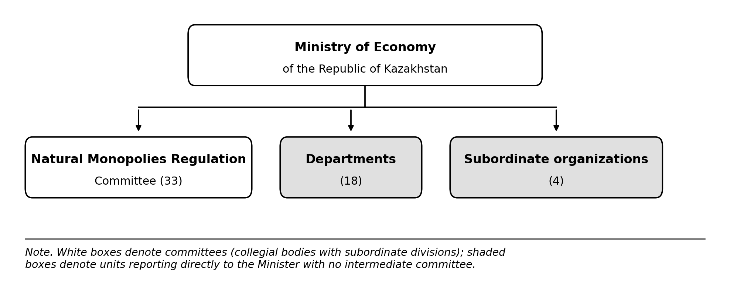
Figure S4: Simplified organizational structure of the Ministry of Economy of the Republic of Kazakhstan. Central-apparatus functions are distributed across one committee (Natural Monopolies Regulation), organized into functional divisions and twenty regional (territorial) departments, alongside departments and subordinate organizations that report directly to the Minister. Full unit names, organizational categories, and parent bodies are provided in Table S5.

Table S4: Full listing of organizational units within the Ministry of Economy of the Republic of Kazakhstan (n = 55), by category and parent body.

No. | Category | Unit name | Parent body
1 | Committee division | Internal administration | Natural Monopolies Regulation Committee
2 | Committee division | Personnel management service (HR service) | Natural Monopolies Regulation Committee
3 | Committee division | Information security | Natural Monopolies Regulation Committee
4 | Committee division | Finance and public procurement | Natural Monopolies Regulation Committee
5 | Committee division | Strategic analysis and international integration | Natural Monopolies Regulation Committee
6 | Committee division | Legal support | Natural Monopolies Regulation Committee
7 | Committee division | Methodology | Natural Monopolies Regulation Committee
8 | Committee division | Railway transport and ports regulation | Natural Monopolies Regulation Committee
9 | Committee division | Oil and gas transportation regulation | Natural Monopolies Regulation Committee
10 | Committee division | Electric power regulation | Natural Monopolies Regulation Committee
11 | Committee division | Water supply and drainage regulation | Natural Monopolies Regulation Committee
12 | Committee division | Heat power regulation | Natural Monopolies Regulation Committee
13 | Committee division | Control and claims/litigation work | Natural Monopolies Regulation Committee
14 | Territorial department | Regulation Department: Astana city | Natural Monopolies Regulation Committee
15 | Territorial department | Regulation Department: Almaty city | Natural Monopolies Regulation Committee
16 | Territorial department | Regulation Department: Almaty region | Natural Monopolies Regulation Committee
17 | Territorial department | Regulation Department: Atyrau region | Natural Monopolies Regulation Committee
18 | Territorial department | Regulation Department: Akmola region | Natural Monopolies Regulation Committee
19 | Territorial department | Regulation Department: Aktobe region | Natural Monopolies Regulation Committee
20 | Territorial department | Regulation Department: East Kazakhstan region | Natural Monopolies Regulation Committee
21 | Territorial department | Regulation Department: Zhambyl region | Natural Monopolies Regulation Committee
22 | Territorial department | Regulation Department: West Kazakhstan region | Natural Monopolies Regulation Committee
23 | Territorial department | Regulation Department: Karaganda region | Natural Monopolies Regulation Committee
24 | Territorial department | Regulation Department: Kostanay region | Natural Monopolies Regulation Committee
25 | Territorial department | Regulation Department: Kyzylorda region | Natural Monopolies Regulation Committee
26 | Territorial department | Regulation Department: Mangystau region | Natural Monopolies Regulation Committee
27 | Territorial department | Regulation Department: Pavlodar region | Natural Monopolies Regulation Committee
28 | Territorial department | Regulation Department: North Kazakhstan region | Natural Monopolies Regulation Committee
29 | Territorial department | Regulation Department: Turkestan region | Natural Monopolies Regulation Committee
30 | Territorial department | Regulation Department: Shymkent city | Natural Monopolies Regulation Committee
31 | Territorial department | Regulation Department: Abai region | Natural Monopolies Regulation Committee
32 | Territorial department | Regulation Department: Zhetysu region | Natural Monopolies Regulation Committee
33 | Territorial department | Regulation Department: Ulytau region | Natural Monopolies Regulation Committee
34 | Department | Macroeconomic analysis and forecasting | Ministry (direct)
35 | Department | Strategic analysis and development | Ministry (direct)
36 | Department | Economic sector development and investment project monitoring | Ministry (direct)
37 | Department | Tax and customs policy | Ministry (direct)
38 | Department | Entrepreneurship development policy | Ministry (direct)
39 | Department | State support and protection of entrepreneurship | Ministry (direct)
40 | Department | International economic cooperation | Ministry (direct)
41 | Department | Public administration system development | Ministry (direct)
42 | Department | State asset management policy | Ministry (direct)
43 | Department | Regional development | Ministry (direct)
44 | Department | Regional analysis and local self-government development | Ministry (direct)
45 | Department | Budget policy | Ministry (direct)
46 | Department | Investment policy and financial sector development | Ministry (direct)
47 | Department | Social sphere, law enforcement and special agencies development | Ministry (direct)
48 | Department | Legal department | Ministry (direct)
49 | Department | Economics and finance | Ministry (direct)
50 | Department | Internal administration | Ministry (direct)
51 | Department | Human resources | Ministry (direct)
52 | Subordinate organization | JSC "Institute of Economic Research" | Ministry (direct)
53 | Subordinate organization | JSC "Kazakhstan Center for Public-Private Partnership" | Ministry (direct)
54 | Subordinate organization | JSC "National Managing Holding Baiterek" | Ministry (direct)
55 | Subordinate organization | RSI "Scientific Research Institute of Micrography" | Ministry (direct)

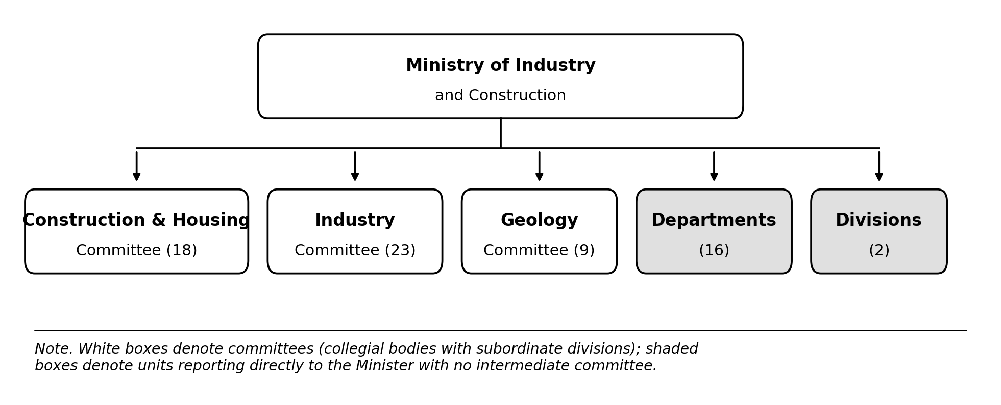
Figure S5: Simplified organizational structure of the Ministry of Industry and Construction of the Republic of Kazakhstan. Central-apparatus functions are distributed across three committees (Construction and Housing-Communal Services, Industry, and Geology), each comprising internal divisions and subordinate organizations, alongside departments and divisions that report directly to the Minister. Full unit names, organizational categories, and parent bodies are provided in Table S5.

Table S4: Full listing of organizational units within the Ministry of Industry and Construction of the Republic of Kazakhstan (n = 68), by category and parent body.

No. | Category | Unit name | Parent body
1 | Committee division | State architectural and construction control | Construction and Housing-Communal Services Committee
2 | Committee division | Housing fund development and housing relations | Construction and Housing-Communal Services Committee
3 | Committee division | Technical regulation and standardization | Construction and Housing-Communal Services Committee
4 | Committee division | Legal support | Construction and Housing-Communal Services Committee
5 | Committee division | Financial affairs | Construction and Housing-Communal Services Committee
6 | Committee division | Communal (utilities) economy | Construction and Housing-Communal Services Committee
7 | Committee division | Water supply and drainage | Construction and Housing-Communal Services Committee
8 | Committee division | Strategic document planning and monitoring | Construction and Housing-Communal Services Committee
9 | Committee division | Housing construction and engineering infrastructure development for new development | Construction and Housing-Communal Services Committee
10 | Committee division | Architecture, urban planning and urban planning cadastre | Construction and Housing-Communal Services Committee
11 | Committee division | Construction cost-estimate norms | Construction and Housing-Communal Services Committee
12 | Committee division | Design and project works | Construction and Housing-Communal Services Committee
13 | Committee division | Licensing and certification monitoring and control | Construction and Housing-Communal Services Committee
14 | Committee division | State architectural and construction control (Committee unit) | Construction and Housing-Communal Services Committee
15 | Subordinate organization | RSE "Gosexpertiza" (State Expertise) | Construction and Housing-Communal Services Committee
16 | Subordinate organization | JSC "Kazcenter ZHKH" | Construction and Housing-Communal Services Committee
17 | Subordinate organization | RSE "Gosgradkadastr" (State Urban Planning Cadastre) | Construction and Housing-Communal Services Committee
18 | Subordinate organization | JSC "KazNIISA" (Kazakh Research Institute of Construction and Architecture) | Construction and Housing-Communal Services Committee
19 | Committee division | Non-ferrous metallurgy and rare metals | Industry Committee
20 | Committee division | Legal service and state services monitoring | Industry Committee
21 | Committee division | Ferrous metallurgy | Industry Committee
22 | Committee division | Construction industry and woodworking | Industry Committee
23 | Committee division | Automotive industry and agricultural machinery | Industry Committee
24 | Committee division | Cross-sectoral coordination | Industry Committee
25 | Committee division | Identification of specific goods | Industry Committee
26 | Committee division | Energy saving and energy efficiency | Industry Committee
27 | Committee division | Electrical engineering and heavy machinery | Industry Committee
28 | Committee division | Light industry | Industry Committee
29 | Committee division | Chemical industry | Industry Committee
30 | Committee division | Non-ferrous metallurgy and rare metals | Industry Committee
31 | Committee division | Coal industry | Industry Committee
32 | Committee division | Policy and state control of specific goods | Industry Committee
33 | Committee division | Licensing and control of specific goods | Industry Committee
34 | Committee division | Manufacturing industry projects | Industry Committee
35 | Committee division | Strategic and program document monitoring | Industry Committee
36 | Committee division | Finance and administrative affairs | Industry Committee
37 | Subordinate organization | JSC "Management Company of the Chemical Park Special Economic Zone" | Industry Committee
38 | Subordinate organization | RSE "National Center for Complex Processing of Mineral Raw Materials" | Industry Committee
39 | Subordinate organization | RSE "National Center for Technology Forecasting" | Industry Committee
40 | Subordinate organization | JSC "Institute for Electric Power Industry and Energy Saving Development (Kazakhenergo)" | Industry Committee
41 | Subordinate organization | RSE "Zhezkazganredmet" | Industry Committee
42 | Committee division | Personnel affairs and corporate development | Geology Committee
43 | Committee division | Geological study of subsoil, geology and hydrogeology | Geology Committee
44 | Committee division | Automation and state services | Geology Committee
45 | Committee division | Subsoil condition monitoring | Geology Committee
46 | Committee division | Expertise and unified cadastre | Geology Committee
47 | Committee division | Finance and administrative affairs | Geology Committee
48 | Committee division | Geological information and strategic planning | Geology Committee
49 | Committee division | Legal and documentation support | Geology Committee
50 | Subordinate organization | JSC "National Geological Service" | Geology Committee
51 | Department | Industrial policy | Ministry (direct)
52 | Department | Subsoil use | Ministry (direct)
53 | Department | Internal audit | Ministry (direct)
54 | Department | Strategic planning | Ministry (direct)
55 | Department | Personnel service | Ministry (direct)
56 | Department | Defense-industrial complex | Ministry (direct)
57 | Department | Integration and international cooperation | Ministry (direct)
58 | Department | Legal department | Ministry (direct)
59 | Department | Public communications | Ministry (direct)
60 | Department | Control and documentation support | Ministry (direct)
61 | Department | Urban planning and housing-communal policy | Ministry (direct)
62 | Department | Digital transformation | Ministry (direct)
63 | Department | Industrial infrastructure development | Ministry (direct)
64 | Department | Subsoil use monitoring and development | Ministry (direct)
65 | Department | Domestic value development | Ministry (direct)
66 | Department | Finance | Ministry (direct)
67 | Division | Mobilization preparedness | Ministry (direct)
68 | Division | State secrets protection | Ministry (direct)

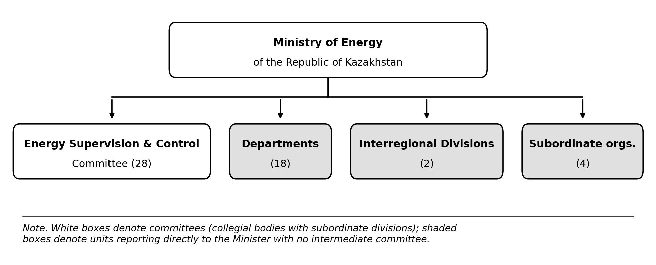
Figure S6: Simplified organizational structure of the Ministry of Energy of the Republic of Kazakhstan. Central-apparatus functions are distributed across one committee (State Energy Supervision and Control), organized into functional divisions and twenty regional (territorial) departments, alongside departments, interregional divisions, and subordinate organizations that report directly to the Minister. Full unit names, organizational categories, and parent bodies are provided in Table S6.

Table S6: Full listing of organizational units within the Ministry of Energy of the Republic of Kazakhstan (n = 52), by category and parent body.

No. | Category | Unit name | Parent body
1 | Committee division | Control of heat networks and boiler houses | State Energy Supervision and Control Committee
2 | Committee division | Control of electrical networks and electrical installations | State Energy Supervision and Control Committee
3 | Committee division | Control of electric and heat generating stations | State Energy Supervision and Control Committee
4 | Committee division | Territorial department monitoring and qualification knowledge testing | State Energy Supervision and Control Committee
5 | Committee division | Personnel affairs | State Energy Supervision and Control Committee
6 | Committee division | Legal service | State Energy Supervision and Control Committee
7 | Committee division | Finance and public procurement | State Energy Supervision and Control Committee
8 | Committee division | Internal administration | State Energy Supervision and Control Committee
9 | Territorial department | Energy Supervision Department: Astana city | State Energy Supervision and Control Committee
10 | Territorial department | Energy Supervision Department: Almaty city | State Energy Supervision and Control Committee
11 | Territorial department | Energy Supervision Department: Shymkent city | State Energy Supervision and Control Committee
12 | Territorial department | Energy Supervision Department: Almaty region | State Energy Supervision and Control Committee
13 | Territorial department | Energy Supervision Department: Akmola region | State Energy Supervision and Control Committee
14 | Territorial department | Energy Supervision Department: Aktobe region | State Energy Supervision and Control Committee
15 | Territorial department | Energy Supervision Department: Atyrau region | State Energy Supervision and Control Committee
16 | Territorial department | Energy Supervision Department: East Kazakhstan region | State Energy Supervision and Control Committee
17 | Territorial department | Energy Supervision Department: Zhambyl region | State Energy Supervision and Control Committee
18 | Territorial department | Energy Supervision Department: West Kazakhstan region | State Energy Supervision and Control Committee
19 | Territorial department | Energy Supervision Department: Karaganda region | State Energy Supervision and Control Committee
20 | Territorial department | Energy Supervision Department: Kostanay region | State Energy Supervision and Control Committee
21 | Territorial department | Energy Supervision Department: Pavlodar region | State Energy Supervision and Control Committee
22 | Territorial department | Energy Supervision Department: Mangystau region | State Energy Supervision and Control Committee
23 | Territorial department | Energy Supervision Department: North Kazakhstan region | State Energy Supervision and Control Committee
24 | Territorial department | Energy Supervision Department: Turkestan region | State Energy Supervision and Control Committee
25 | Territorial department | Energy Supervision Department: Abai region | State Energy Supervision and Control Committee
26 | Territorial department | Energy Supervision Department: Zhetysu region | State Energy Supervision and Control Committee
27 | Territorial department | Energy Supervision Department: Ulytau region | State Energy Supervision and Control Committee
28 | Territorial department | Energy Supervision Department: Kyzylorda region | State Energy Supervision and Control Committee
29 | Department | Subsoil use | Ministry (direct)
30 | Department | Gas industry | Ministry (direct)
31 | Department | Press service | Ministry (direct)
32 | Department | Oil transportation and processing | Ministry (direct)
33 | Department | Oil development and production | Ministry (direct)
34 | Department | State control in oil and gas sectors | Ministry (direct)
35 | Department | Petrochemicals and technical regulation | Ministry (direct)
36 | Department | Electric power development | Ministry (direct)
37 | Department | Renewable energy sources | Ministry (direct)
38 | Department | Strategic development | Ministry (direct)
39 | Department | Appeals control and executive discipline | Ministry (direct)
40 | Department | Legal service | Ministry (direct)
41 | Department | Budget and financial procedures | Ministry (direct)
42 | Department | International cooperation | Ministry (direct)
43 | Department | Digitalization | Ministry (direct)
44 | Department | Personnel policy | Ministry (direct)
45 | Department | Administrative affairs | Ministry (direct)
46 | Department | Current security issues | Ministry (direct)
47 | Interregional division | RSI "Southern Interregional Directorate of State Inspection in the Oil and Gas Complex" | Ministry (direct)
48 | Interregional division | RSI "Western Interregional Directorate of State Inspection in the Oil and Gas Complex" | Ministry (direct)
49 | Subordinate organization | LLP "Settlement and Financial Center for Renewable Energy Support" | Ministry (direct)
50 | Subordinate organization | JSC "Kazakhstan Electricity and Capacity Market Operator" | Ministry (direct)
51 | Subordinate organization | JSC "Situational-Analytical Center of the Fuel and Energy Complex" | Ministry (direct)
52 | Subordinate organization | JSC "Management Company of the National Industrial Petrochemical Technopark Special Economic Zone" | Ministry (direct)

